Lab Assignment -1
Name : M . Raja
HT.No : 2303A52277
Batch : 36

Environment Setup – GitHub Copilot and VS Code Integration + Understanding AI-assisted Coding Workflow
Task 0
Install and configure GitHub Copilot in VS Code. Take screenshots of each step.
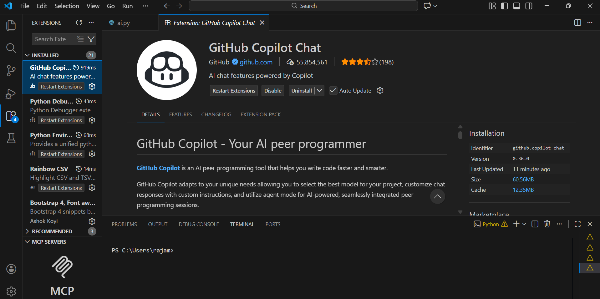

Task 1: AI-Generated Logic Without Modularization (String Reversal Without Functions)
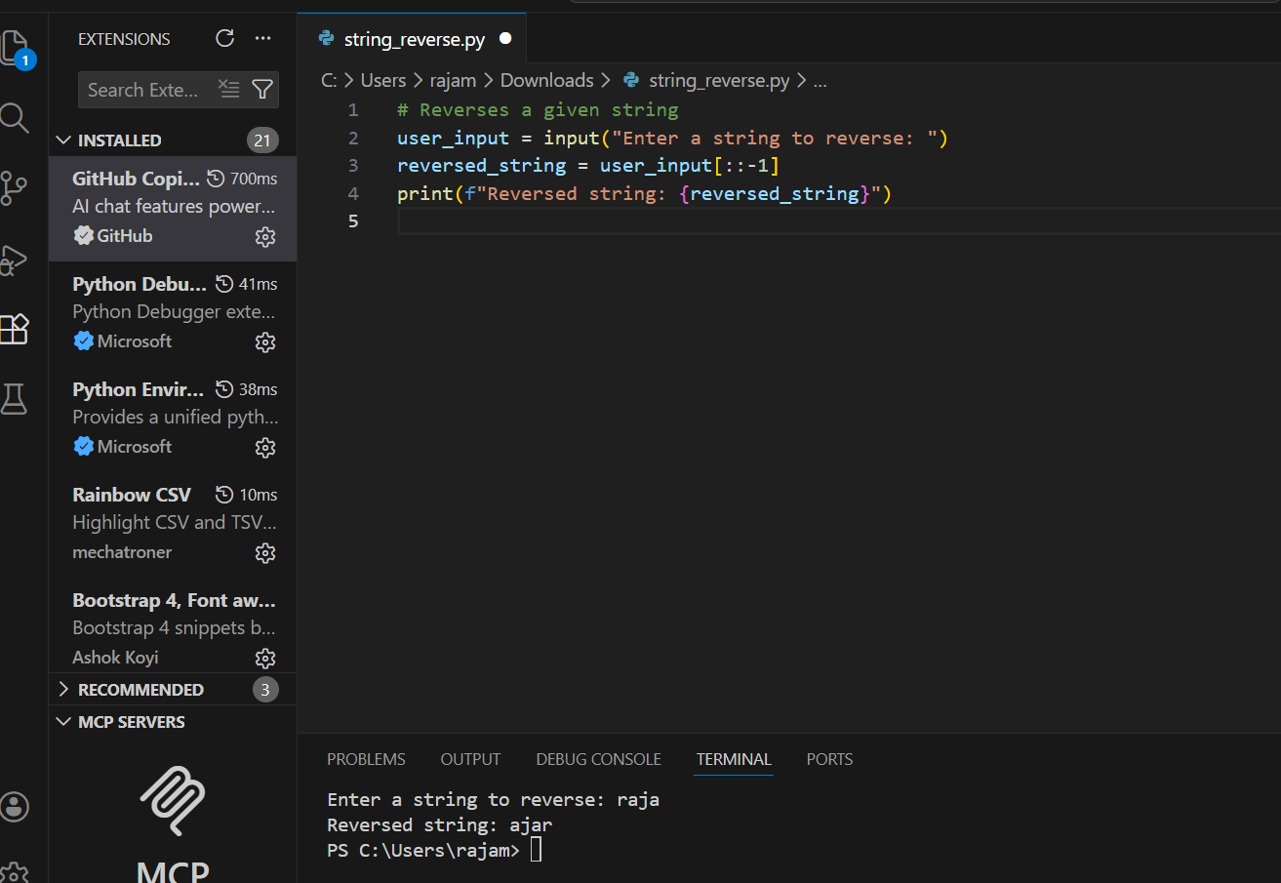
Task 2: Efficiency & Logic Optimization (Readability Improvement)
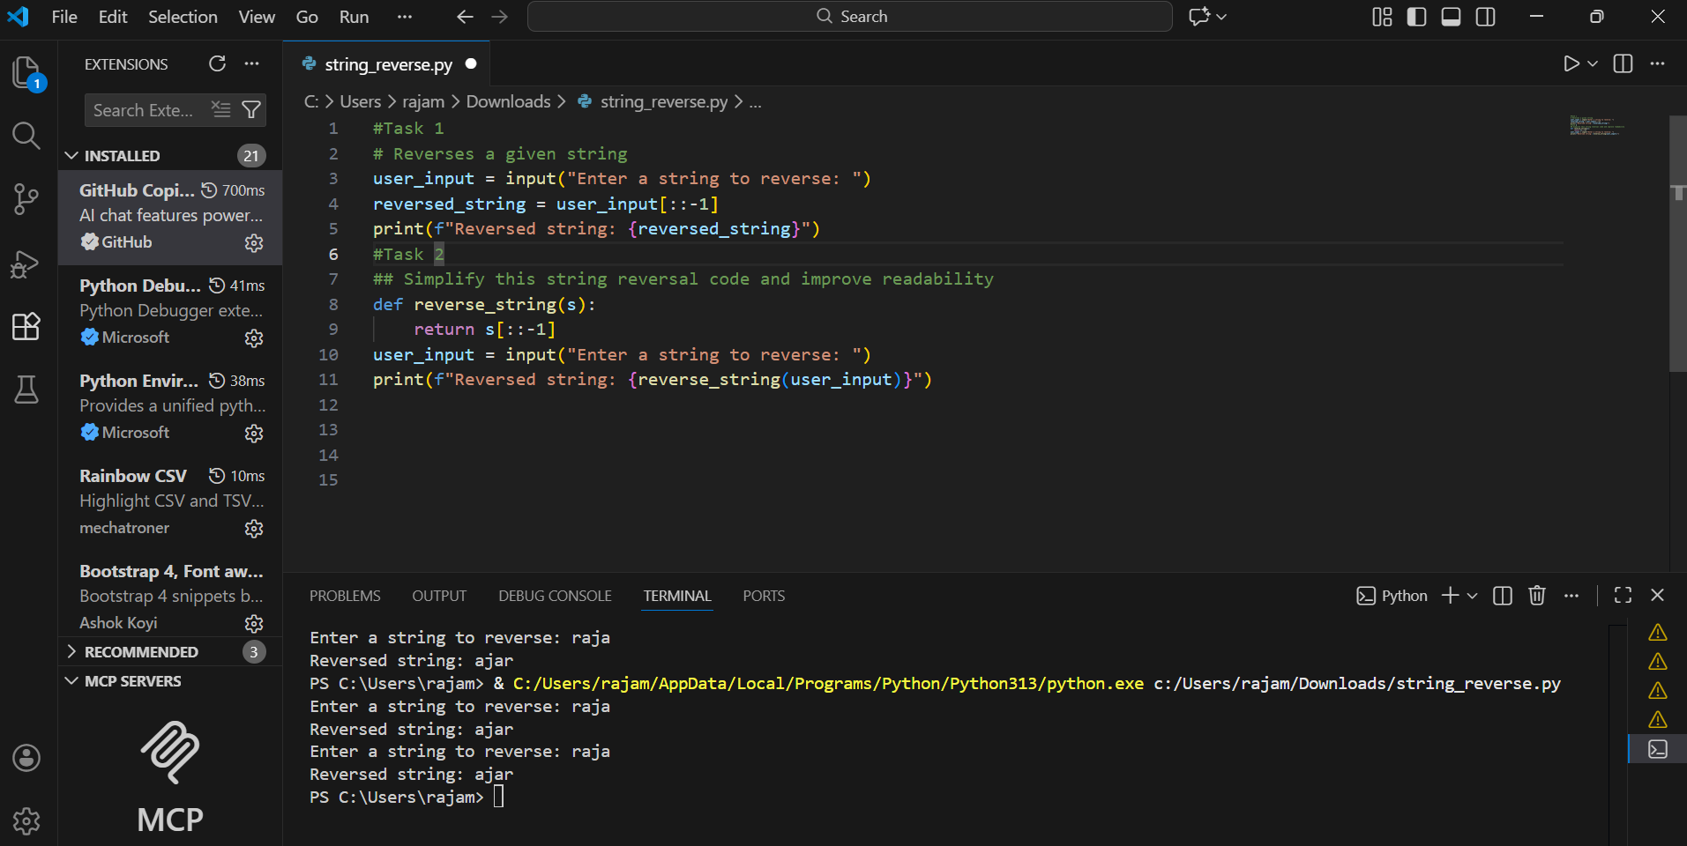
Explanation : In Task 2, the original string reversal code was optimized by removing unnecessary variables and simplifying the logic.
The loop and intermediate variable were eliminated, and Python slicing was used directly.
This improved readability and reduced code length.
Both versions have a time complexity of O(n), but the optimized version is more efficient in practice due to fewer operations.
Task 3: Modular Design Using AI Assistance (String Reversal Using Functions)
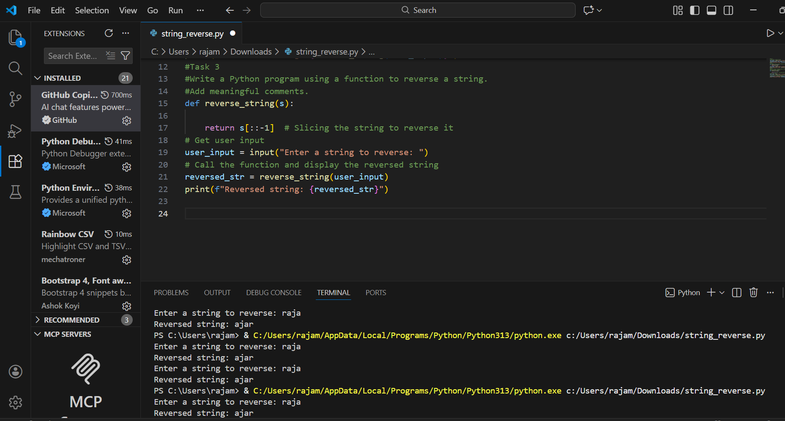
Explanation
- The function reverse_string() encapsulates the string reversal logic
- It uses Python slicing ([::-1]) for efficient reversal
- The function returns the reversed string to the caller
- This modular approach allows reuse of the same logic in multiple parts of an application
- Meaningful comments improve code readability and understanding

Task 4: Comparative Analysis – Procedural vs Modular Approach (With vs Without Functions)
Comparison Table
Criteria | Without Functions (Procedural) | With Functions (Modular)
Code Clarity | Logic is mixed with input/output, making it less clear | Logic is separated into a function, improving clarity
Reusability | Code cannot be reused easily | Function can be reused in multiple parts of the application
Debugging Ease | Harder to debug due to lack of separation | Easier to debug and test individual functions
Maintainability | Changes must be made in multiple places | Changes can be made in one function
Scalability | Not suitable for large programs | Suitable for large-scale applications

Task 5: AI-Generated Iterative vs Recursive Fibonacci Approaches (Different Algorithmic Approaches to String Reversal)
  - A loop-based string reversal approach
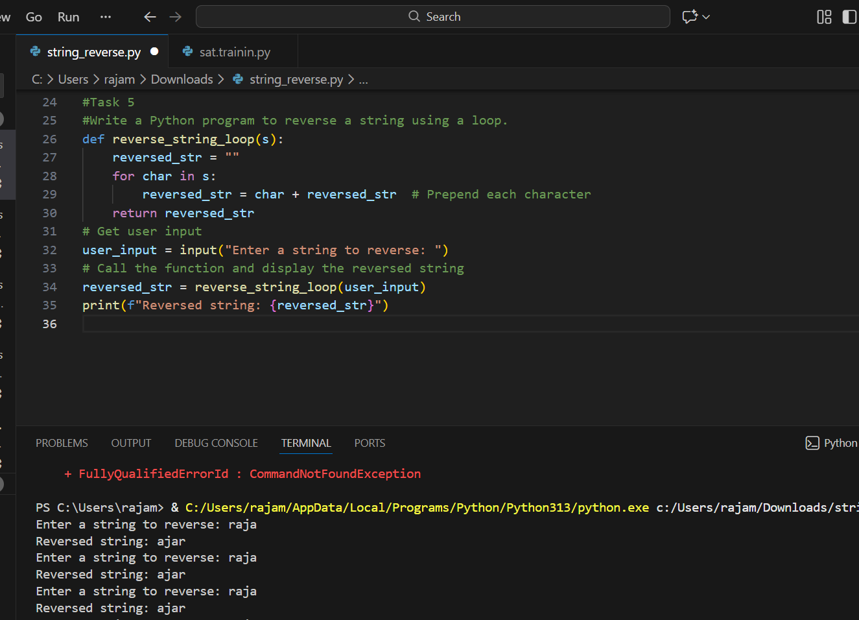
  - A built-in / slicing-based string reversal approach
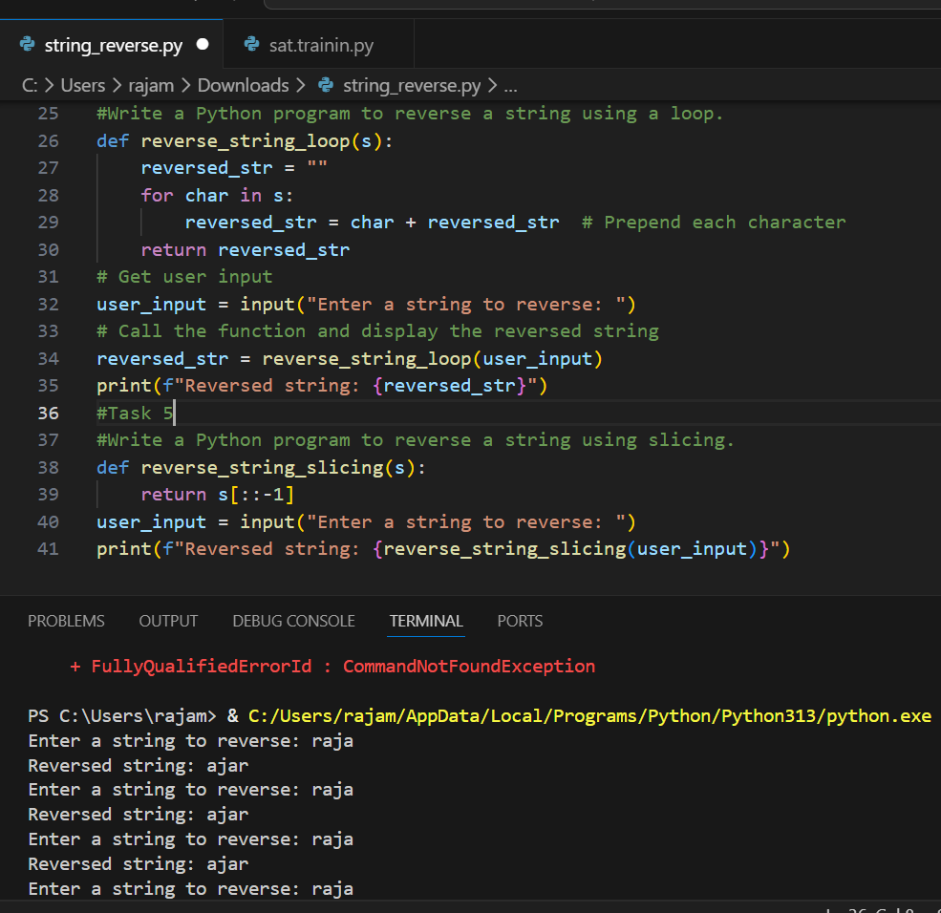
2. Time Complexity
- Loop-Based Approach:
Time complexity is O(n), where n is the length of the string.
- Built-in Approach:
Time complexity is also O(n), as the string must be traversed internally.
Conclusion
Although both approaches have the same time complexity, the built-in slicing method is more efficient and readable, making it the preferred choice for practical applications.

